**Using MS-Excel with ODBC Database Tables**

**to do Updates and Reporting**

|  |  |
| --- | --- |
| **SCHOOL:** | Algonquin College |
| **COURSE NUMBER:** | CST8276_030 Advanced Database Topics |
| **PROFESSOR:** | Amal Ahmed Anda |
| **PREPARED BY:** | Group 3 |
| **TEAM MEMBER:** | Cao, Dandan [cao00102@algonquinlive.com](mailto:cao00102@algonquinlive.com)  Song, Xiao [song0137@algonquinlive.com](mailto:song0137@algonquinlive.com)  Chang, lijun [chan0529@algonquinlive.com](mailto:chan0529@algonquinlive.com)  Li, Jinwei [li000464@algonquinlive.com](mailto:li000464@algonquinlive.com)  Yang, Haiyan [yang0348@algonquinlive.com](mailto:yang0348@algonquinlive.com)  Huang, Ziyang [huan0269@algonquinlive.com](mailto:huan0269@algonquinlive.com) |
| **DATE OF SUBMISSION:** | May 25, 2024 |

Table of Contents

Introduction 3

Topic Description Paragraphs 3

Why we chose this topic 3

Problem Description 5

Who 5

What 5

Where 5

When 6

Why 6

How 6

Solution Demonstration Description 7

Introduction of solution demonstration 7

Risks 8

Work Plan 9

Table with components and deliverables 9

Reference 11

# Introduction

## Topic Description Paragraphs

Microsoft Excel is an essential tool for daily office work due to its user-friendly interface and powerful features. It is one of the most widely used spreadsheet application for data-related tasks. Excel's capabilities and scalability make it useful for tasks such as data collection, cleaning, cataloging, and visualization. It plays a crucial role in various data-related tasks and can be integrated with databases through Open Database Connectivity (ODBC). This allows users to establish a direct connection between Excel and different database systems, enabling real-time data loading to ensure the timeliness and completeness of data sets.

By utilizing ODBC, Excel can serve as a robust front-end interface for interacting with back-end databases, facilitating seamless data exchange and ensuring that the information in Excel is always current and consistent with the database. Users can also execute SQL queries, retrieve data sets, update records, and generate detailed reports directly from Excel, streamlining workflows and enhancing productivity [1][2].

Additionally, Excel's powerful reporting tools, such as pivot tables, charts, and data models, can be linked to databases through ODBC. This allows for the creation of interactive and up-to-date reports, making it easier to monitor and analyze data [3]. By integrating Excel with databases via ODBC, users can efficiently perform data updates and reporting tasks [4].

## Why we chose this topic

We have chosen the topic of Using MS-Excel with ODBC Database Tables to do Updates and Reporting due to its practical relevance and wide applicability. Excel is a commonly used tool for data collection and management, with a user-friendly interface and powerful features that make it essential for various data tasks. As a Database Administrator, its functionality, integrating Excel with databases through ODBC, can be greatly enhanced, allowing for real-time data loading and ensuring the accuracy and timeliness of the data set. This integration also simplifies workflows significantly.

In both academic projects and co-op work, we have encountered situations where we needed to load raw data from Excel into databases, making this a highly applicable technology. Therefore, this topic not only deepens our understanding of database management and data analysis, but also prepares us to handle practical challenges in a variety of professional settings.

# Problem Description

## Who

* As a data administrator who is responsible for maintaining data integrity, accuracy, and accessibility within an organization.
* Data analyst who relies on the accurate data to do the analysis work
* End-users leverage it for decision-making
* Other stockholder in the organization works with the data

## What

The data aspect of the issue involves ensuring that data collected and managed in Excel is accurately transferred, synchronized, and updated within the database systems. Data administrators must ensure that the data pipelines work smoothly, which includes handling data consistency, managing data loads, and implementing data quality control measures. This responsibility is crucial to maintain the reliability and usability of the data across various systems.

## Where

This problem is predominantly client-side, where DBAs need to establish and maintain efficient connections between Excel and backend databases using ODBC. It also involves server-side considerations, such as ensuring the database server can handle real-time data requests and replication processes to prevent discrepancies between the database and Excel.

## When

Timing aspects include scheduling regular data updates and synchronizations between Excel and the database to ensure data timeliness. DBAs need to manage periodic data loads, real-time data retrieval during operational hours, and scheduled report generations to ensure data is always current and accurate.

## Why

DBAs must adhere to various laws and regulations, and other industry-specific data protection standards to ensure data privacy, security, and integrity. This adherence is to avoid legal ramifications, or compromised decision-making.

## How

Issues arise when there is a failure in the data exchange process between Excel and the database, leading to data inconsistencies and inefficiencies. DBAs can resolve these issues by implementing automated data synchronization, regular testing, monitoring processes, and logging and reviewing.

# Solution Demonstration Description

## Introduction of solution demonstration

In the solution demo, we will show how to use MS-Excel with ODBC (Open Database Connection) database tables to perform updates and generate reports, with a focus on COVID-19 statistics and charts. The presentation will cover the following key components and steps:

**Components**

* MS-Excel
* ODBC Driver
* Oracle

**Scripts**

* **Database initialization script:** SQL script to create the necessary tables and insert the initial data.
* **Data update script:** SQL script to update new COVID-19 data to the database.
* **ODBC Configuration Script:** Instructions or scripts that configure the ODBC driver and data source name (DSN) to ensure that MS-Excel can connect to the database.

**Database Setup**

* **Table Structure:** A table designed to store COVID-19 statistics, such as daily cases, recoveries, deaths, and vaccination status. Example data shown below in Figure 1 [5].

Figure 1:

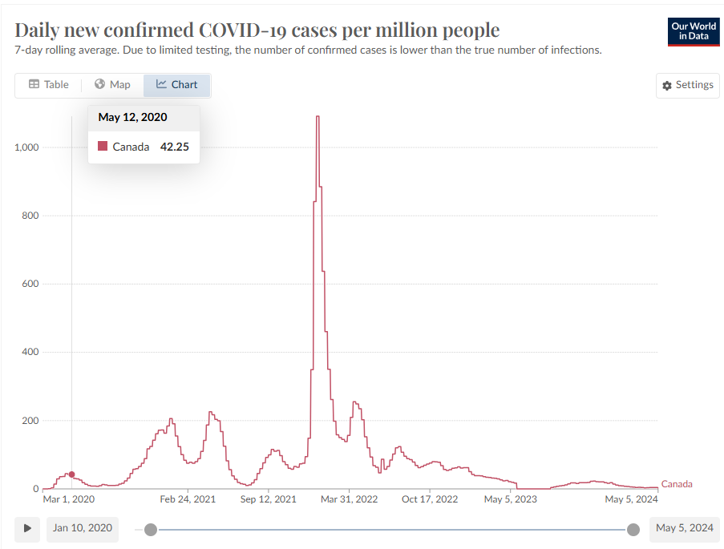

* **Data Insertion:** Insert sample data into a table for demonstration purposes.
* **Data Source Configuration:** Set up and configure ODBC data sources on systems using MS-Excel.

## Risks

**Known risks include:**

* System stability connection between MS-Excel, ODBC Driver, and MySQL.
* Data quality and format match between multiple MS-Excel and Database
* The source and correctness of the data.
* Regular system update and maintenance
* Security issues, periodically check logs to check data update results and check whether there are illegal logins

# Work Plan

## Table with components and deliverables

|  |  |  |  |
| --- | --- | --- | --- |
| **Component/**  **Deliverable Name** | **Time Period** | **Hours Excepted** | **Responsible Individual** |
| Initial Proposal | Week3-4 | 10 | Cao, Dandan  Li, Jinwei  Yang, Haiyan  Huang, Ziyang  Song, Xiaosong  Chang, Lijun |
| Final Proposal | Week5 | 10 | Cao, Dandan  Li, Jinwei  Yang, Haiyan  Huang, Ziyang  Song, Xiaosong  Chang, Lijun |
| Database Environment Setup | Week6 | 20 | Cao, Dandan  Li, Jinwei  Yang, Haiyan  Huang, Ziyang  Song, Xiaosong  Chang, Lijun |
| Search data related to COVID-19 | Week7 | 20 | Cao, Dandan  Li, Jinwei  Yang, Haiyan  Huang, Ziyang  Song, Xiaosong  Chang, Lijun |
| Generate statistics & graphic reports | Week8 | 30 | Cao, Dandan  Li, Jinwei  Yang, Haiyan  Huang, Ziyang  Song, Xiaosong  Chang, Lijun |
| Testing and Validation | Week9-10 | 25 | Cao, Dandan  Li, Jinwei  Yang, Haiyan  Huang, Ziyang  Song, Xiaosong  Chang, Lijun |
| Report | Week11 | 10 | Cao, Dandan  Li, Jinwei  Yang, Haiyan  Huang, Ziyang  Song, Xiaosong  Chang, Lijun |
| Presentation | Week12-13 | 10 | Cao, Dandan  Li, Jinwei  Yang, Haiyan  Huang, Ziyang  Song, Xiaosong  Chang, Lijun |

# Reference

[1]. Phil Factor, "Getting Data between Excel and SQL Server using ODBC - Simple Talk," Redgate Hub, Aug. 16, 2013. [Online].Available: <https://www.red-gate.com/simple-talk/databases/sql-server/database-administration-sql-server/getting-data-between-excel-and-sql-server-using-odbc/> [Accessed: May 23, 2024]

[2]. "Use Microsoft Query to retrieve external data," Microsoft Support. Available: <https://support.microsoft.com/en-us/office/use-microsoft-query-to-retrieve-external-data-42a2ea18-44d9-40b3-9c38-4c62f252da2e> [Accessed: May 23, 2024]

[3]. "How to Use Excel to Script Database Table Updates," Segue Technologies, Dec. 3, 2013. [Online]. Available: <https://www.seguetech.com/excel-script-database-table-updates/> [Accessed: May 23, 2024]

[4]. "Connect to an ODBC Data Source (SQL Server Import and Export Wizard)," Microsoft Learn, Sep. 1, 2023. [Online]. Available: <https://learn.microsoft.com/en-us/sql/integration-services/import-export-data/connect-to-an-odbc-data-source-sql-server-import-and-export-wizard?view=sql-server-ver16> [Accessed: May 23, 2024]

1. H. Ritchie, E. Mathieu, L. Rodés-Guirao, C. Appel, C. Giattino, J. Hasell, B. Macdonald, S. Dattani, D. Beltekian, and M. Roser, “Coronavirus Pandemic (COVID-19),” Our World in Data. <https://ourworldindata.org/covid-cases> [Accessed May 24, 2024].